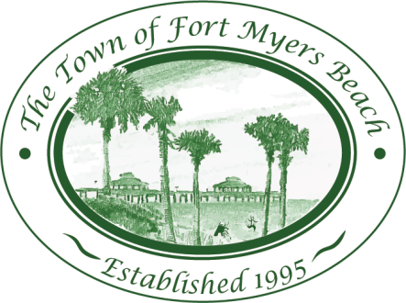
Town of Fort Myers Beach

LOCAL PLANNING AGENCY
Town Hall – Council Chambers
2523 Estero Boulevard
Fort Myers Beach, Florida
33931
February 10, 2015

AGENDA (all time frames are informational and approximate) 9:00 AM

- Call to Order
- Invocation
- Pledge of Allegiance
- Minutes
  - Minutes of January 13, 2015 LPA meeting 5 minutes
- Discussion
  - Evaluation and Appraisal Report 20 minutes
  - Post-disaster Recovery and Reconstruction 30 minutes
  - Estero Boulevard Project update 15 minutes

Adjourn as LPA and reconvene as Historic Preservation Board
Adjourn as Historic Preservation Board and reconvene as LPA

- LPA Member Items and Reports 15 minutes
- LPA Attorney Items 5 minutes
- Community Development Items 5 minutes
- LPA Action Item List Review 10 minutes
- Items for next month’s Agenda 10 minutes
- Public Comment
- Adjournment

Next Meeting: March 10. 2015

 | For special accommodations, please notify the Town Clerk’s Office at least 72 hours in advance. (239) 765-0202 |  | Help for the hearing impaired is available through the Assistive Listening System. Receivers can be obtained from the Town Clerk’s Office.

