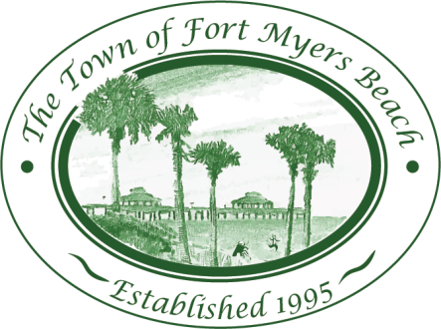
Town of Fort Myers Beach

LOCAL PLANNING AGENCY
Town Hall – Council Chambers
2523 Estero Boulevard
Fort Myers Beach, Florida
33931
April 14, 2015

AGENDA (all time frames are informational and approximate) 9:00 AM

- Call to Order
- Invocation
- Pledge of Allegiance
- Minutes
  - Minutes of March 10, 2015 LPA meeting 5 minutes

- Public Hearing 30 minutes
  - VAR2014-0002 – Sign Variance Request for the Lani Kai Resort
    - Original Application Materials
    - Staff Report
    - Application Supplemental Information
    - Correspondence with Applicant’s Agent
    - Variance Resolutions
    - Illuminated Sign Study
    - Site Aerial

- Discussion 75 minutes
  - Evaluation and Appraisal Report
    - Review Utilities
    - Review Stormwater Management Element
      - Town of FMB Stormwater Assessment Program
      - Executive Summary – Stormwater Master Plan
    - Review Public Schools Elements
  - Post-disaster Recovery and Reconstruction 60 minutes

Adjourn as LPA and reconvene as Historic Preservation Board
Adjourn as Historic Preservation Board and reconvene as LPA

- LPA Member Items and Reports 15 minutes
- LPA Attorney Items 5 minutes
- Community Development Items 5 minutes
- LPA Action Item List Review 10 minutes
- Items for next month’s Agenda 10 minutes
- Public Comment
- Adjournment

Next Meeting: May 12, 2015

 | For special accommodations, please notify the Town Clerk’s Office at least 72 hours in advance. (239) 765-0202 |  | Help for the hearing impaired is available through the Assistive Listening System. Receivers can be obtained from the Town Clerk’s Office.

