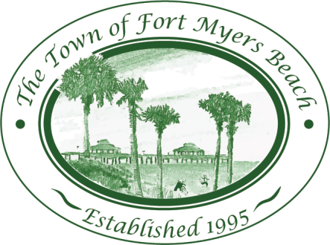
Town of Fort Myers Beach

LOCAL PLANNING AGENCY
Town Hall
2525 Estero Boulevard
Fort Myers Beach, Florida
33931
October 13, 2015

AGENDA 9:00 AM

- Call to Order
- Invocation
- Pledge of Allegiance

- Minutes
  - Minutes of September15, 2015 LPA meeting

- EAR Discussion
  - Review of Elements
    - Historic Preservation Element
    - Intergovernmental Coordination Element (ICE)
    - Capital Improvements Element (CIE)

- LPA Member Items and Reports
- LPA Attorney Items
- Community Development Items
- Items for next month’s Agenda
- Public Comment
- Adjournment

Next Meeting: November 10, 2015

 | For special accommodations, please notify the Town Clerk’s Office at least 72 hours in advance. (239) 765-0202 |  | Help for the hearing impaired is available through the Assistive Listening System. Receivers can be obtained from the Town Clerk’s Office.

